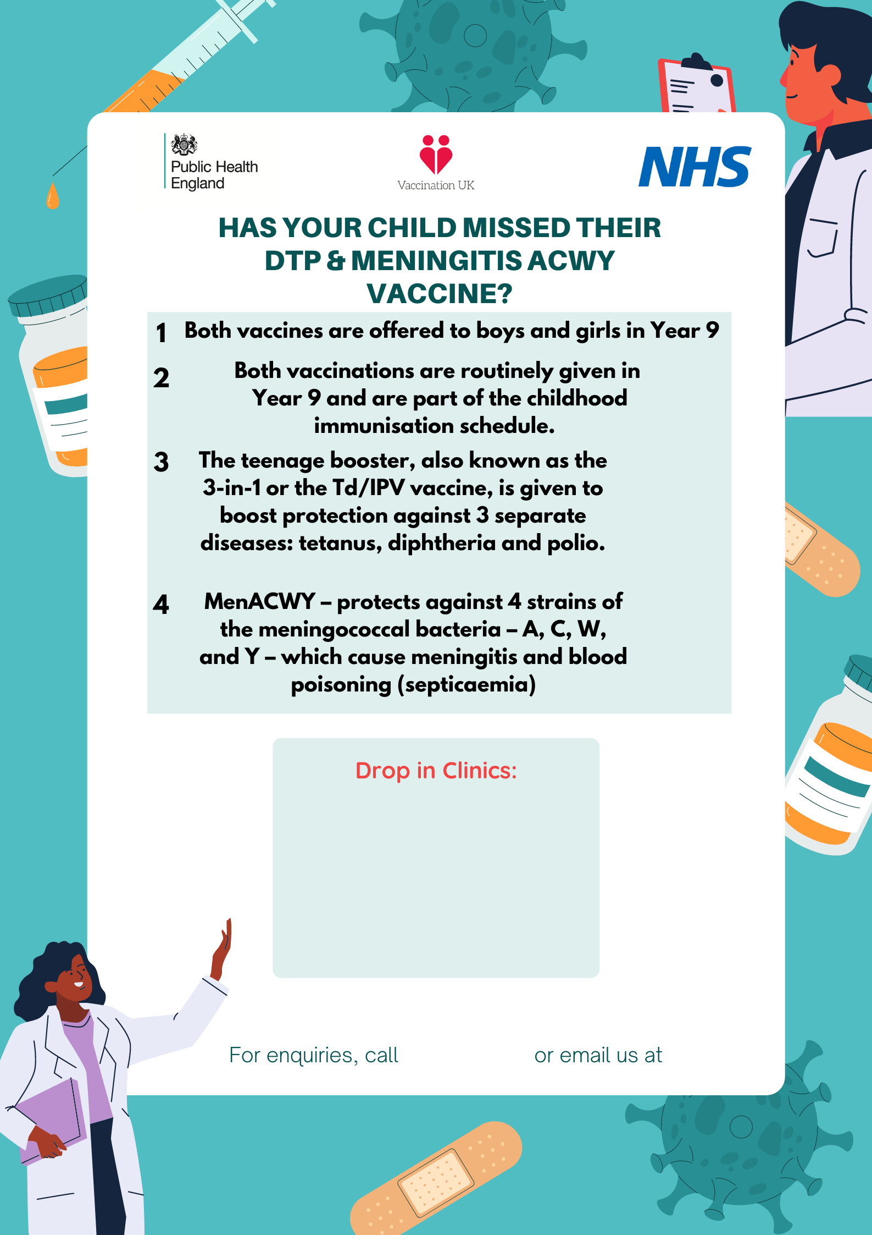 newham@v-uk.co.uk

On: Monday 30th May 2022

At: The Beckton Globe Library

1, Kingsford Way,

E6 5JQ

Between: 10.30am – 2pm

02082141395