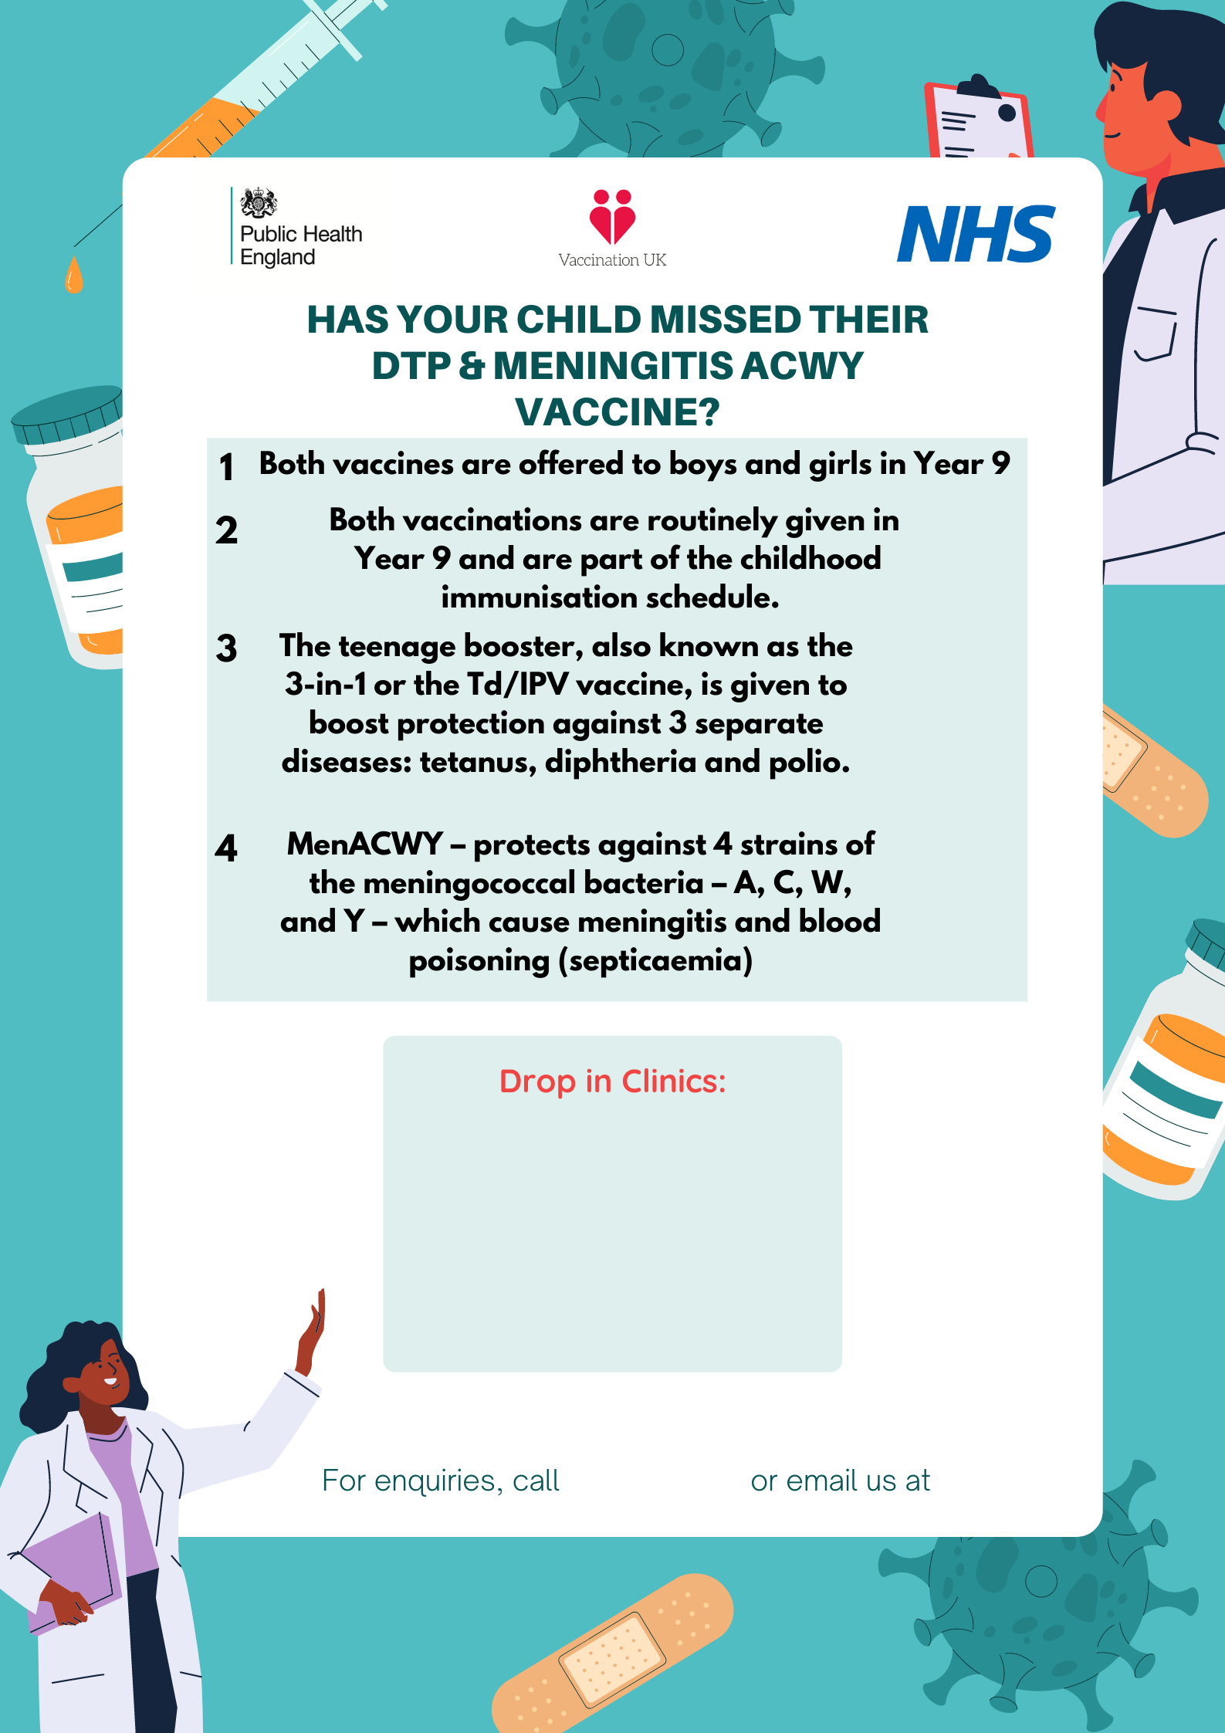
newham@v-uk.co.uk

02082141395
On: Wednesday 1st June 2022
At: Vicarage Lane Health Centre,
10 Vicarage Lane E15 4ES
Between: 10am – 2pm

