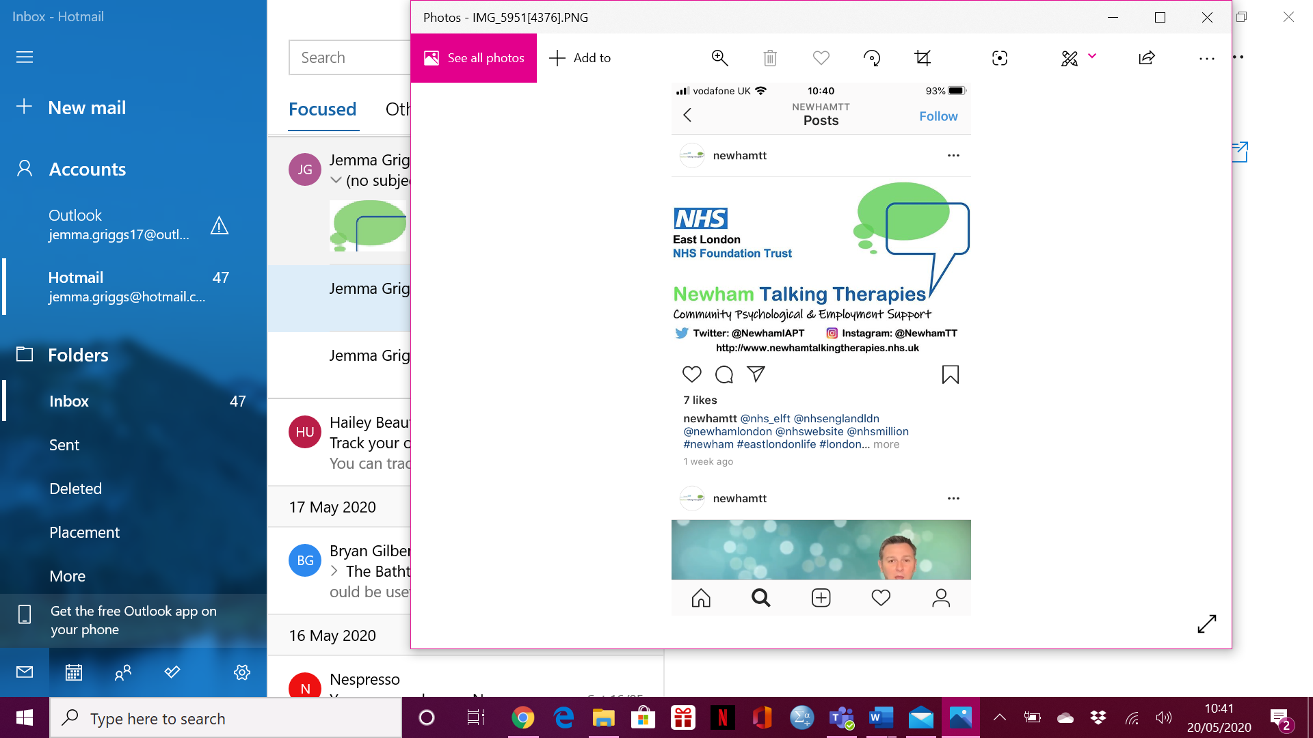

**Online Workshop**

**Understanding Bereavement**

**FRIDAY 29TH MAY 2020**

**10:00AM – 11:15AM**

**CALL 0208 475 8080 OR EMAIL** [**elft.nttworkshops@nhs.net**](mailto:elft.nttworkshops@nhs.net)

**TO REGISTER**