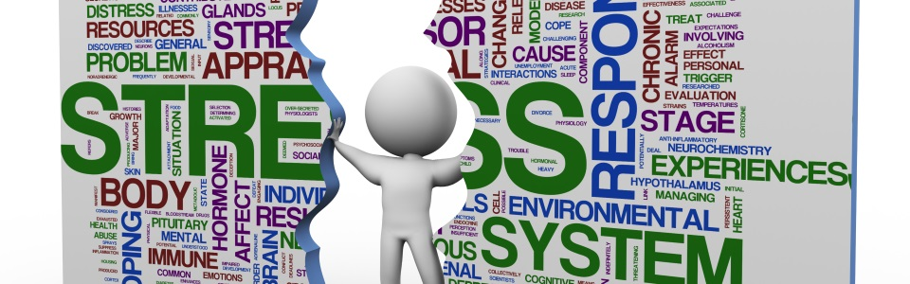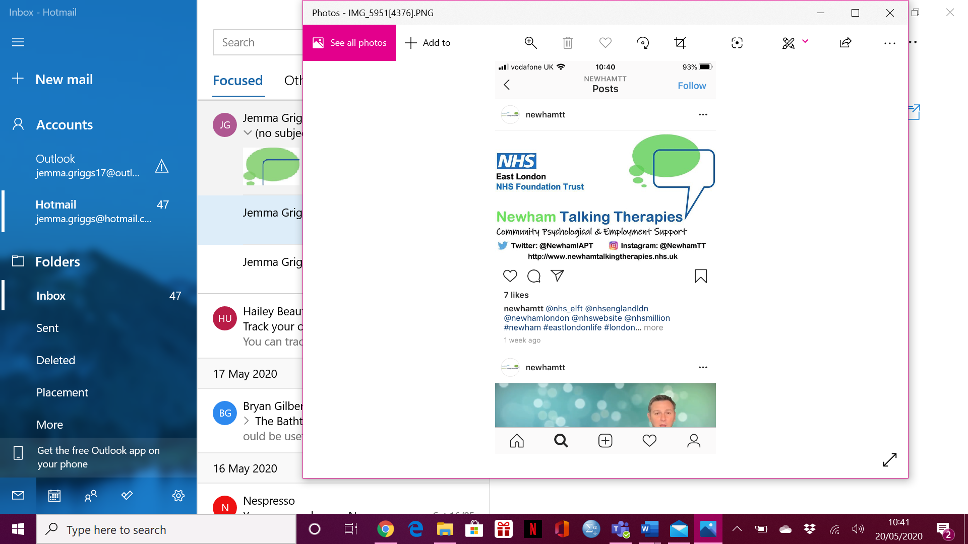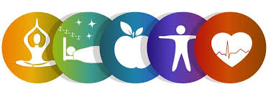

**Managing Stress**

**Online Workshop**

**CALL 0208 475 8080 OR EMAIL** [**elft.nttworkshops@nhs.net**](mailto:elft.nttworkshops@nhs.net)

**TO REGISTER**

**THURSDAY 28TH MAY 2020**

**10:00AM – 11:00AM**