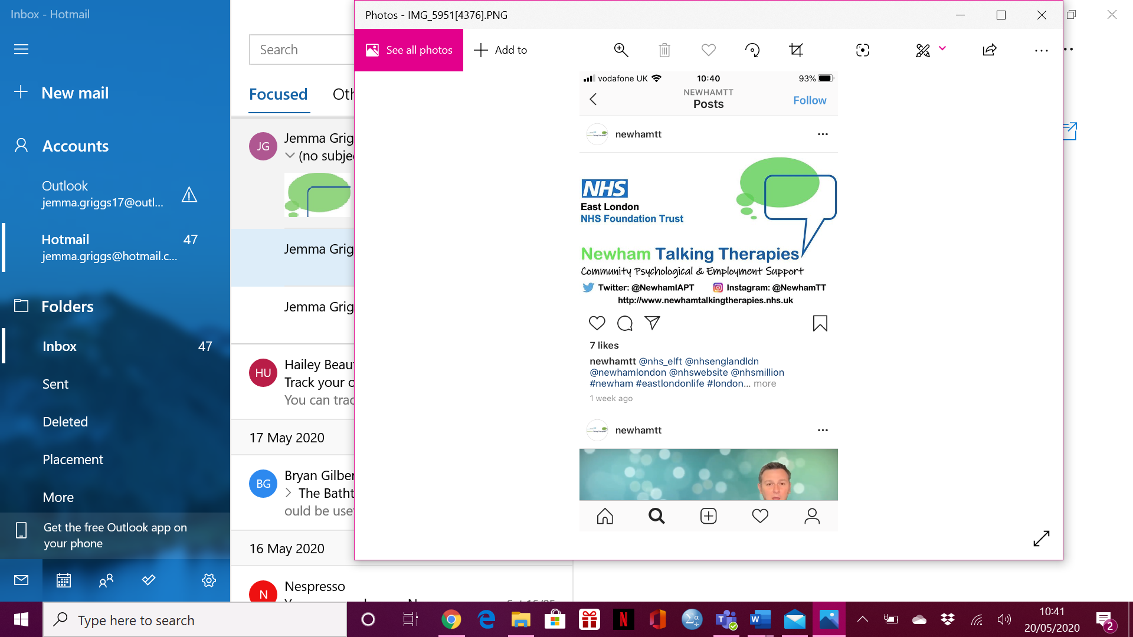

**COVID-19**

**Online Support Group**

**Keeping Well During a Pandemic**

**4 WEDNESDAYS from 17:00pm – 18:15pm**

**STARTING MONDAY 1ST JUNE 2020**

**FOR RESIDENTS OF THE BOROUGH OF NEWHAM OR IF YOU ARE REGISTERED WITH A GP IN NEWHAM**

**CALL 0208 475 8080 TO REGISTER**