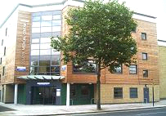
Dr M.S.J. Khan
152 Barking Road,
East Ham, London. E6 3BD
Tel/Fax: 020 8475 8500/8501
BOLEYN MEDICAL CENTRE

7th October 2019

Statement regarding CQC inspection conducted in July 2019

The Surgery had a review Care Quality Commission (CQC) inspection on 22/07/2019 and 25/07/2019. The overall result was classified as an Inadequate rating after achieving a Good rating 3 years prior.
The Surgery was dissatisfied with the conduct and methodology of the visit and lodged a formal complaint on 9/09/2019. We are awaiting the response from CQC in regards to the formal complaint.

Nevertheless we acknowledge that there are areas that can be improved and enhanced and we are working hard to implement this.
We feel confident that review process in the next few months will achieve a satisfactory result.

For any further question please contact the Practice Manager.

Dr MSJ Khan & Practice Team

